CASTLESIDE VILLAGE FESTIVAL
STATIC VEHICLES & DISPLAYS – ARRIVAL & SITE BRIEFING
Saturday 12 September 2026 | Daytime festival 13:00–16:00
Location: Castleside, Co. Durham, DH8 9QY
What3Words: ///shops.blur.blame
Static vehicles and community displays are part of the daytime festival. Where possible, vehicles must be positioned before the public activity period.

KEY TIMES & ACCESS
Time | Requirement | Notes
12:30 | Drover Road closure begins (outside village hall) | Fire Appliance to be located on Drover Road (13:30- 15:30) and will remain operational with a clear exit required at all times.
12:30–13:00 | Recommended arrival / positioning window | Where possible, vehicles should arrive and be positioned before the public activity period.
13:00 | Displays open | Static vehicles and displays operate 13:00–16:00.
16:00 | Displays finish | Public display period ends. Vehicles should remain in place until safe to depart.
16:30 | Drover Road closure ends
LOCATION
School Field: Static Vehicles & Displays are located on the School Field in the designated area shown on the Event Site Plan below.
Fire Appliance is planned on Drover Road during the road closure to allow for a prompt operational departure.
Access to the School Field is from the A692 (Consett Road) via Moorland Crescent & Drover Terrace, shown via the red line on the map below.
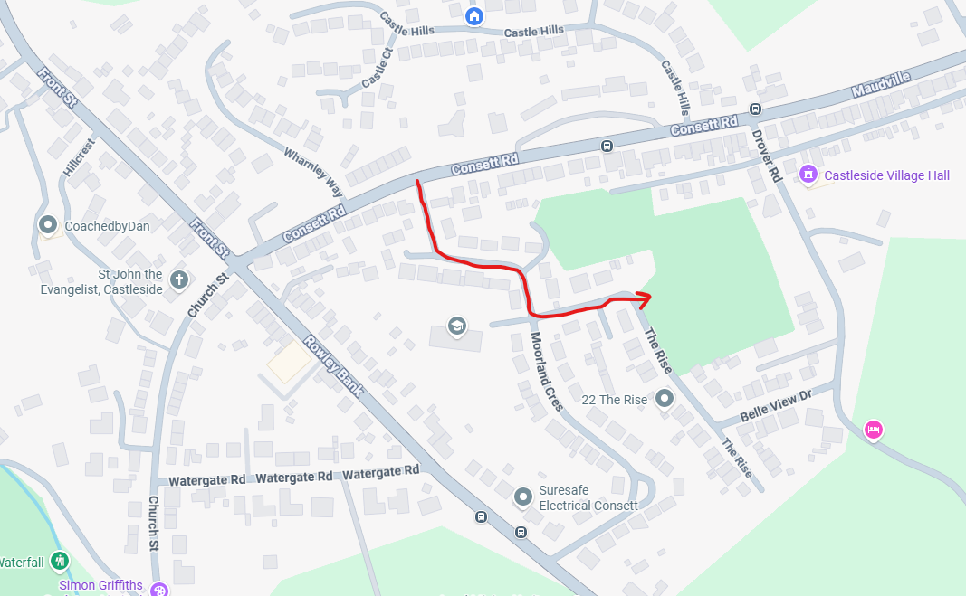
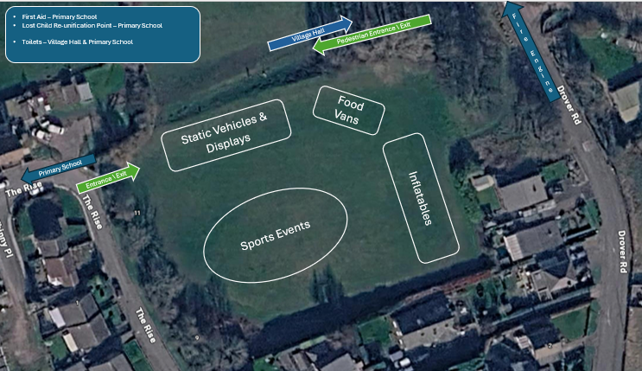

ARRIVAL & DEPARTURE INSTRUCTIONS
• Do not arrive at the School Field before 12:30.
• Vehicles must be positioned as directed and must not obstruct emergency access, pedestrian entrances/exits or other displays.
• Once positioned, vehicles should not be moved during the public display period unless authorised by the Event Lead.
• The Fire appliance must have a clear route to leave the site immediately if required for an emergency response.
• Drivers should remain contactable throughout the event.
• Any vehicle with gas, electrical equipment or other operational hazards must comply with its own safety arrangements and provide required documentation to the Event Lead upon request.

EVENT CONTACT: Event Lead – Ian Robson – 07999 985 548

