Procedure:  ICT401 | Northumbria Blood Bikes Procedure:  Registering Member Milestones
Owner: | ICT Officer | Author: | Michael Thompson
Approved: | 6 March 2017 | By: | Executive Committee
Doc Ref | ICT401 | Version | 1.0

- Why do we need this Procedure
This document sets out how to register and manage member milestones using the website milestones facility.
- Who is Responsible for this Procedure
The ICT Officer of the group is responsible for the maintenance of this procedure.
The Executive Committee is responsible for approving this procedure.
C. When will this Procedure be reviewed
The procedure will be reviewed a maximum of one year following its approval.
D. How will changes be notified
The latest version of the policy will be made available via the members’ library on the group website. New versions will be announced via email to all qualified milestone administrators and the executive committee.
- Aim of Procedure
  - This procedure explains how to register and manage member milestones using the website milestones facility. This procedure should distribute the workload in registering member accreditation and allow for automation as additional forms and spreadsheets will no longer be required.
  - The central milestones system will also allow reminders to be sent automatically to those whose timebound milestones are due to expire.
- Registering a Milestone
  - The milestone system allows those who are responsible for member accreditations to register the dates (and any additional information associated with the event) that the events happen. Milestones currently covered include
    - Driving License Checks
    - Assessment Rides
    - Assessment Drives
    - Ride-Alongs (for Riders & Drivers or Shift Controllers)
    - Attendance at Member Induction
    - Attendance at Shift Controller Workshop
    - Attendance at Blue Lights Workshop
    - Attendance at Trailer Assessment
    - Joining or Leaving Shift Controller Register
    - NEAS Keys – Issued or Returned – deployment in progress

  - In order to register a milestone, a member needs to have access to the Northumbria Blood Bikes website, access to the milestones facility and to be logged in at the time of booking.
  - To prevent over complication of the system, and to allow a degree of flexibility, all users of the milestone system will be able to register all milestones types. It is, of course, expected that this flexibility will not be abused by those entrusted with access.
  - Registering a milestone requires entry of common information and the milestone type. Depending on the milestone type, further information may be added to the record. Fields that are not relevant to any entry will be hidden from view.
  - Depending on the role being performed access to the milestone registration form may be available via menus – these will be advised for each role – or the form is always available via the URL:
http://www.northumbriabloodbikes.org.uk/members/add-milestone

Common Information
  - There are four pieces of information required for every milestone:
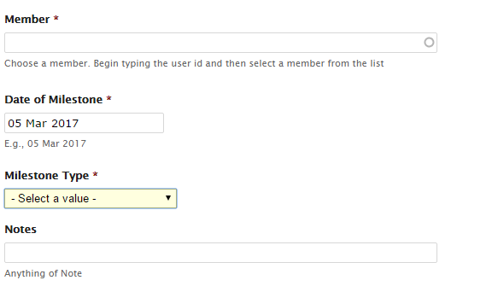

    - Member Name : This is entered into the text box. The text box operates as a search box, by typing in part of a members username a list of matched usernames will appear, choose the correct member from the list. If there are so many matches that the member you require doesn’t appear in the list, keep typing until the list shortens and your member appears.
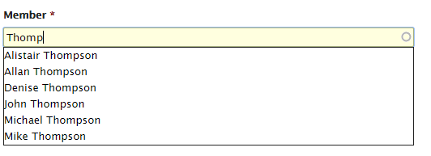

    - Date of Milestone : Record the date that the check was performed. Today’s date will be the default entry – clicking in the entry box will pop-up a calendar to choose a different date.
    - Milestone Type: Choose the type of event / milestone you are recording. This may result in extra input being displayed. Variations for each milestone type are explained below.
    - Notes: There is a text box to enter any notes for this milestone. For certain milestones this field will be used for specific information but in all instances it may be used to annotate the milestone with any variations or notable information.
    - Once all of the information is entered for a milestone, scroll to the bottom of the form and click [Save]

- Driving License Checks
  - Navigate to the Create Member Milestones form.
  - Enter the common information, Member Name and Date
  - Milestone Type: Select Miletone Type “Driving License Check, additional fields will be displayed:
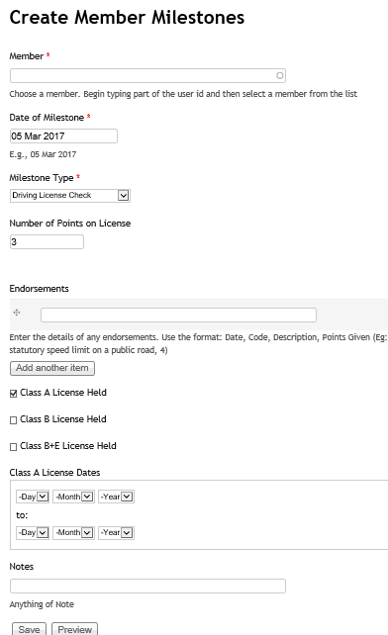
  - Penalty Points: Enter the number of penalty points on the member’s License.
  - Endorsements: if there are endorsements, enter the details in the field that appears when points on license is greater than 0.
  - Class A License: Indicate via the tick box if the member holds a Class A license. If so, additional fields will be displayed to record the dates the license is valid.
  - Class B License: Indicate via the tick box if the member holds a Class B license. If so, additional fields will be displayed to record the dates the license is valid.
  - Class B+E License: Indicate via the tick box if the member holds a Class B+E license. If so, additional fields will be displayed to record the dates the license is valid.
  - Notes: Add any notes that are required.
  - Once all of the information is entered for a milestone scroll to the bottom of the form and click [Save]

- Member Ride Alongs
  - Data Entry
Only the basic fields are required to enter a ride along
Enter the Member Name, Date, and chose the type of Ride-Along Completed.
If required add any comments to the notes section.

- Assessment Rides or Assessment Drives
  - Data Entry
Only the basic fields are required to enter an Assessment Ride or Drive
Enter the Member Name, Date, and chose Assessment Ride or Assessment Drive as the milestone type.
For a first assessment add “Initial” in the notes section, for subsequent assessments enter “Annual”.

- Attendance at Induction, Shift Controller Workshop, Blue Lights Workshop or Trailer Familiarisation
  - Data Entry
Only the basic fields are required to enter a ride-along
Enter the Member Name, Date, and chose the type of workshop attended as the milestone type.
If required add any comments to the notes section.

- NEAS Keys.
  - Data Entry
Only the basic fields are required to track NEAS Keys
Enter the Member Name, Date, and chose the NEAS Key as the milestone type.
Enter the Key Number and “Issued” or “Returned” as appropriate in the notes section.

- MHRA Assessment.
  - Data Entry
Only the basic fields are required to track NEAS Keys
Enter the Member Name, Date, and chose the MHRA Assessment as the milestone type.
Enter the any comments as appropriate in the notes section.

- Reviewing and Reporting.
  - To view or edit Milestones you have entered.
    - Depending on the role being performed access to the milestones already entered may be available via menus – these will be advised for each role – or the a view of milestones entered by any member is always available via the URL:
http://www.northumbriabloodbikes.org.uk/members/milestones-wip
    - From the list of milestones entered the detail for each record may viewed, updated or deleted as appropriate.

  - To view a member’s own milestones
    - A member may view all milestones that they have reached (and we have recorded) from the URL:
http://www.northumbriabloodbikes.org.uk/members/milestones-mine
    - Eventually this view will be incorporated into the information provided when a member accesses the “my account” section of the website.

  - To manage all milestones
    - Those with the need (and appropriate access rights) may view (and edit) all milestones recorded. The milestones may be viewed by member, or by milestone types. The view is available at the URL:
http://www.northumbriabloodbikes.org.uk/members/milestones-filtered

Northumbria Blood Bikes Procedure:
Registering Attendance at an event
Version Control and History
Date | Version | Author: | Reason For Change
Nov 2016 | 1.0 | Graham Moor | First Version of event booking system

