Northumbria Blood Bikes Use of Pool Car
A temporary agreement is in situ to allow Northumbria Blood Bikes volunteers use of the Trust’s Nissan Leaf Pool Car. This provision is made to ensure that services which transport items on behalf of the Trust can be maintained in conditions which mean the motorbike may not be used.
The process
- The Blood Bike volunteer will attend Freeman Hospital Main Reception and advise that the car is required.
- The Receptionist will request completion of Volunteer Pool Car Request Form.
- The volunteer must complete all fields and sign the form.
- The Receptionist will provide the volunteer with the Pool Car Envelope containing keys, charge card, guidance and inspection sheet.
- The volunteer will proceed to the Red Car Park and leave their own vehicle (i.e. motorbike or car) in this car park and leave the site in the pool car following inspection and recording of mileage.
- The volunteer will return the car to its designated space in the Red Car Park and if range remaining is below 20 miles place the car on charge.
- The volunteer should return the keys, charge card, guidance and inspection sheet to the Main Reception at Freeman Hospital and advise if there have been any issues.
- The Receptionist should provide the volunteer with the Volunteer Pool Car Request Form to confirm the vehicle is returned.
- A member of the Transport and Facilities Team will collect all items on the morning of the next working day.
Location of Pool Car – Red Car Park
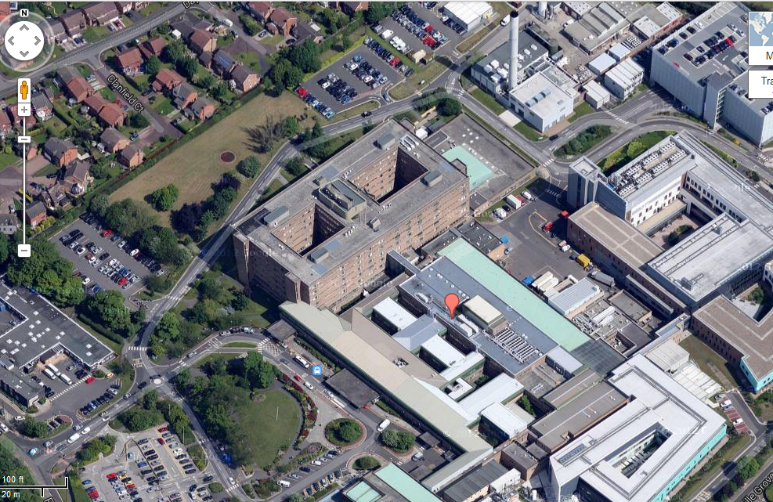

VOLUNTEER POOL CAR REQUEST FORM

To be completed prior to key handover before departure
Volunteer Name:
Date:
Time of Arrival:

Declaration: I can confirm that that I am a volunteer for Northumbria Blood Bikes and that I have provided my identification to the NuTH employee to verify my identity. I can confirm that I require the vehicle for the purposes of Northumbria Blood Bikes work requests.
I can confirm that the guidance provided for the use of the NuTH Nissan Leaf has been read and understood and that I am aware that whilst driving this vehicle as a volunteer for Northumbria Blood Bikes I am providing a service for the Newcastle upon Tyne Hospitals NHS Foundation Trust in accordance with the Service Level Agreement.
I understand and agree that in the event of any accident or damage that any excess due is payable.
I can confirm that I have been provided with keys, charge point card, vehicle guidance and inspection sheet.
Signed:
Vehicle Registration:
NUTH Employee:
Job Title:

To be completed on return of vehicle and keys
Date:
Time of Return:
Declaration: I can confirm that the vehicle has been returned and is on charge / off charge (delete as appropriate), with / without incident (delete as appropriate) and the keys, charge point card, vehicle guidance and inspection sheet are also returned.
Signed:
NUTH Employee:

