Type:  Guide | Northumbria Blood Bikes:  OARS – Hexham Run Activity Recorders – User Guide
Owner: | ICT Officer | Author: | Michael Thompson
Approved: | 1st July 2025 | By: | Executive Committee
Doc Ref | ICT024 | Version | 2.2

- Why do we need this guide
The work that we do, as part of the NHS, can have a direct result on the health and wellbeing of patients. It is important, therefore, that we keep accurate records of the work that we do. This document explains how the Northumbria Blood Bikes Online Activity Recording System should be used by Riders, Drivers and Shift Controllers to record the details of jobs they do as part of the Hexham scheduled run.
- Who is Responsible for this guide
The ICT officer of the group is responsible for the maintenance of this Guide.
The Executive Committee is responsible for approving this Guide.
All riders, drivers and shift controllers are bound by this guide to record run details.
- When will this guide be reviewed
The guide will be reviewed a maximum of Two years following its approval.
- How will changes be notified
The latest version of the guide will be made available via the members’ library on the group website. New versions will be announced via email to all members and the executive committee.

- Why do we record job details
  - The work that we do, as part of the NHS, can have a direct result on the health and wellbeing of patients. It is important, therefore, that we keep accurate records of the work that we do for several reasons:

- We need to report to the Trusts that commission us on the work that we do for them.
- We need to be able to show evidence trails for the jobs that we do as we may be audited by the MHRA and we need to show that our processes are robust.
- We need to review the work that we do against our Service Level Agreements
- We need to monitor the amount of work that we do to ensure that we have planned sufficient operational capacity to deal with our workload without creating undue stress for our volunteers.
- We need accurate records of the work that we do, to inform our fundraising bids as it allows us to demonstrate that grants or gifts from donors will generate real benefits for the local community
  - The paper receipt books that we maintain as jobs are carried out, form one strand of our record keeping but they are not appropriate for the timely & accurate reporting & analysis of our workload as a whole – for that we need to use the Online Activity Recording System (OARS).
  - The Online Activity Recorders are tailored to the type of job being recorded and by whom.
  - This document sets out the user instructions for the following Online Activity Recorders:
- Riders, Drivers and Shift Controllers: deliveries and collections performed during scheduled Hexham runs (ROTA016).

- Accessing the On-Line Activity Recorders.
  - You will need to be logged in to the NBB website to access the activity recorders.

  - All OARS forms automatically record the name of the member who has logged in
  - To use the activity recorders, log in to the website and then from the menus choose:
Operations>On-Line Activity Recording
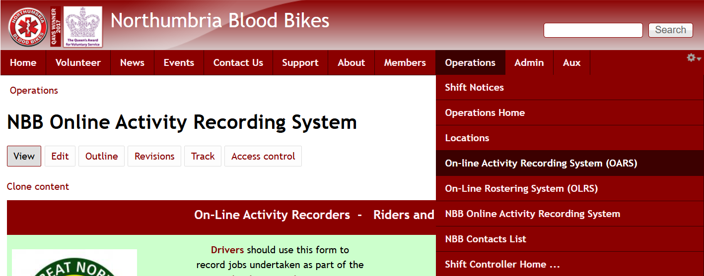
then choose the required Activity Recorder from the options displayed.
  - The activity recorders will contain groups of fields, or multiple pages. The answers given in the earlier fields, influence which questions are displayed later.
Answer all questions that are displayed.
Items marked with a red asterisk * must be answered.
If a question is asked, but that action was not undertaken then 0 (zero) should be entered as the Job Receipt Number (JRN) for that action. This lets us know that the action was not required this time (as opposed to the question being missed) and allows the form to adjust accordingly.
  - A scheduled run consists of a sequence of predetermined locations with assigned actions (collections and deliveries) at each location. This allows the activity recorder for a scheduled run to streamline the data input since there are known, pre-determined variables for each job.
The standard activity recorder should be used for all jobs not carried out as part of a scheduled Hexham run, and for any jobs that are ‘piggy-backed’ onto a scheduled run by the shift controller.

- Riders, Drivers and Shift Controllers – Hexham Activity Recorder

  - Set Up Data Entry for This Run
The first group of fields collects general information about the run.
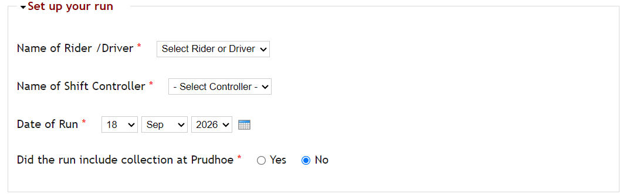
*Name of Rider or Driver: Select the name of the rider or driver for this Hexham Scheduled run from the drop-down list. Once opened, typing characters moves the list quickly to names matching the characters typed.
*Name of Shift Controller: Select the name of the shift controller on shift during this Hexham Scheduled run from the drop-down list. Once opened, typing characters moves the list quickly to names matching the characters.
*Date: Provide the date that the run was completed. You only need to provide this once. All subsequent times entered will be related to this date.
Choose day, month, year from the drop-down lists or use the pop-up calendar.

*Question must be answered

  - Collection at Corbridge Medical Centre
The next group of fields collects the details for the next location – Corbridge Medical Centre
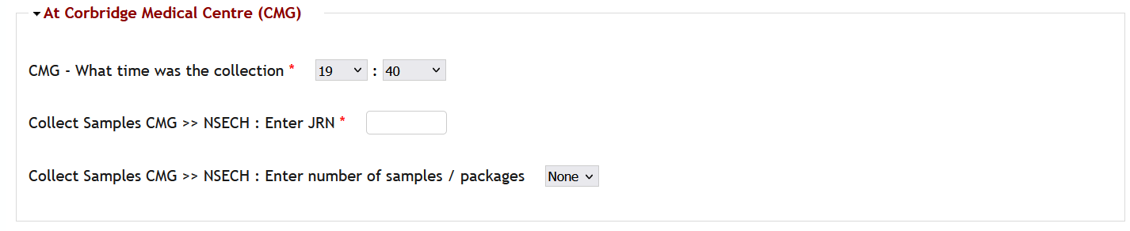
*Time of Collection: Enter the hour and minute for the collections at this location. You only need to enter this once. This time will be applied to all actions at this location.
*Collect Samples (CMG >> NSECH) JRN: Enter the JRN for the samples to be taken to Northumbria Specialist Emergency Care Hospital (NSECH).
If there are no samples for NSECH then enter zero.
** Collect Samples (CMG>> NSECH) Number of packages : Select the number of samples / packages taken to NSECH
** Collect Samples (CMG >> NSECH) Comments: Enter any comments necessary

*Question must be answered
**Question only appears based on earlier answers

  - Collection at Hexham General Hospital
The next group of fields collects the details for the next location – Hexham General Hospital
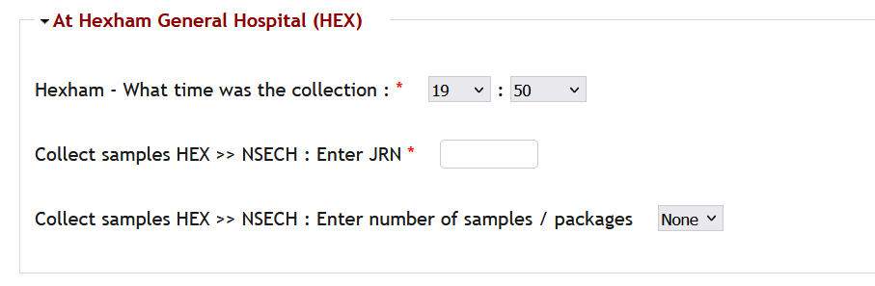
*Time of Collection: Enter the hour and minute for the collections at this location. You only need to enter this once. This time will be applied to all actions at this location.
*Collect Samples (HEX >> NSECH) JRN: Enter the JRN for the samples to be taken to Northumbria Specialist Emergency Care Hospital (NSECH).
If there are no samples for NSECH then enter zero.
** Collect Samples (HEX>> NSECH) Number of packages : Select the number of samples / packages taken to NSECH
** Collect Samples (HEX >> NSECH) Comments: Enter any comments necessary

*Question must be answered
**Question only appears based on earlier answers
  - Delivery at NSECH

The next group of fields collects the details for the next location – NSECH

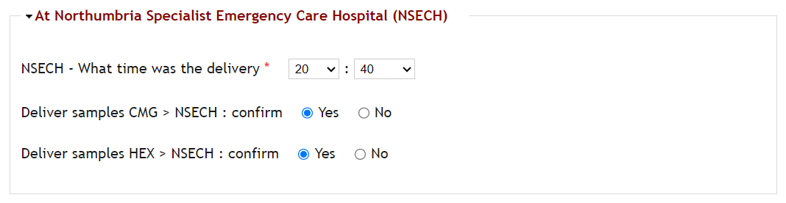
*Time of Delivery: Enter the hour and minute for the delivery of samples at this location. You only need to enter the time once. This time will be applied to all actions at this location. This time must be later than the time at the Hexham collection
**Samples Delivered (CMG >> NSECH): Confirm delivery of the samples from Corbridge.
**Samples Delivered (HEX >> NSECH): Confirm delivery of the samples from Hexham.

*Question must be answered
**Question only appears based on earlier answers
  - Collection at HMP Northumberland

The next group of fields collects the details for the next location – His Majesty’s Prison Northumberland
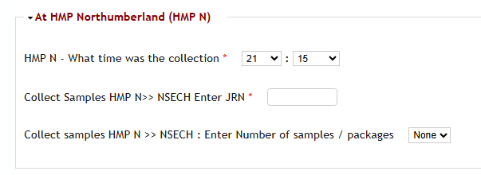
*Time of Collection: Enter the hour and minute for the collections at this location. You only need to enter this once. This time will be applied to all actions at this location and must be after first time at NSECH
*Collect Samples (HMP N >> NSECH) JRN: Enter the JRN for the samples to be taken to NTGH.
If there are no samples for NSECH then enter zero.
** Collect Samples (HMP N >> NSECH) Number of packages : Select the number of samples / packages taken to NSECH
** Collect Samples (HMP N >> NSECH) Comments: Enter any comments necessary

*Question must be answered
**Question only appears based on earlier answers
  - Exchange at NSECH2

The next group of fields collects the details for the next location – NSECH (2nd visit)
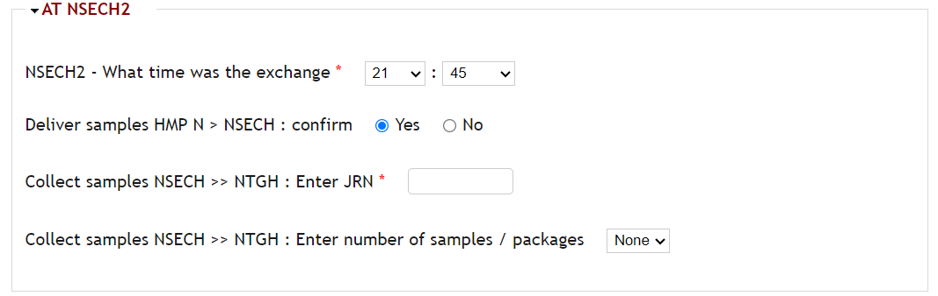
*Time of Exchange: Enter the hour and minute for the exchange of samples at this location. You only need to enter the time once. This time will be applied to all actions at this location. This time must be later than the time at the HMP Northumberland collection
**Samples Delivered (HMP >> NSECH): Confirm delivery of the samples from HMP Northumberland..
*Collect Samples (NSECH >> NTGH) JRN: Enter the JRN for the samples to be taken to North Tyneside General Hospital (NTGH).
If there are no samples for NTGH then enter zero.
** Collect Samples (NSECH >> NTGH) Number of packages : Select the number of samples / packages taken to NNTGH
** Collect Samples (NSECH >> NTGH) Comments: Enter any comments necessary

*Question must be answered
**Question only appears based on earlier answers
  - Delivery at North Tyneside General Hospital
To close off the Hexham run activity enter the data for delivery at NTGH.
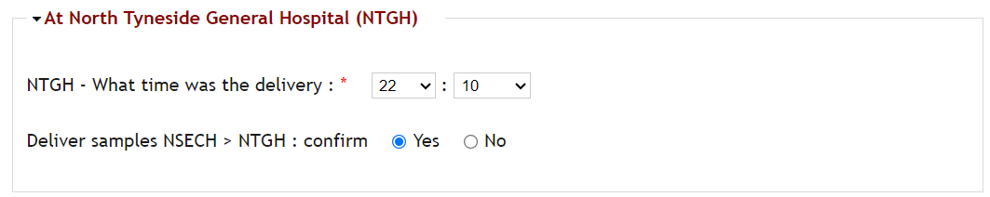
*Time of Collection: Enter the hour and minute for the collections at this location. You only need to enter this once. This time will be applied to all actions at this location. Must be later than second visit at NSECH.
**Deliver Samples (NSECH >> NTGH) Confirm: Confirm delivery of the samples from NSECH

*Question must be answered
**Question only appears based on earlier answers

4. Saving, Checking and Submitting the Data
4.1. At any time during the data entry process the form can be saved as a draft, using the button at the bottom of the form. This allows for the form to be filled in, in stages, while the Hexham run is in progress. At any time if the rider, driver, or controller, returns to the Job Recorder and the system finds a partially completed form, it will be retrieved, and data entry can continue.


4.2. The Job Recorder can, of course, also be completed once the run is complete. A data collection template is available for download from the members’ library to assist with this.

4.3. Once data entry is complete, the data can be reviewed by pressing the [Preview] button. Please, check that the data entered is correct, we do see a significant error rate in completed forms.

Again, the data can be saved as a draft for later review, or correction, if necessary.

Alternatively, you can return to the data entry screen to correct any errors you have found.

4.4. If all the data has been entered correctly then press [Submit]. Remember, your data will only be recorded and entered for processing once you have pressed [Submit]

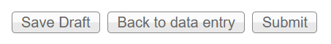

4.5. Once all of the data has been submitted, the Hexham Run Activity Recorder is complete. Thanks for completing the Hexham Run and recording your da

Northumbria Blood Bikes:
Hexham Run Activity Recorders – User Guide
Version Control and History
Date | Version | Author: | Reason For Change
July 2025 | 1.0 | Michael Thompson | First version of this guide – applies to new version of Hexham Run Activity Recorder
July 2026 | 2.0 | Michael Thompson | Guide updated to reflect change in route for Hexham run
September 2026 | 2.1 | Michael Thompson | Guide updated to reflect reversal of change in route for Hexham run
October 2026 | 2.2 | Michael Thompson | Changed again to reflect changes in route and actions performed at NSECH

